|  |
| --- |
| **NUCL 355 Experiment 5** |
| Turbulence and Vortex Visualization in Vertical Channel  Professor S. T. Revankar |
|  |
| School of Nuclear Engineering  Purdue University  Report of the Experiment By:  Weston Cundiff, Stephen Cox, Kara Luitjohan, Patrick Burk, Dominic Ghering, Michael Stryker, Austin Curtis, Matt Metzger, et. Al. |
| **Written By Alex Hagen** |
| **2/22/2011** |
|  |

# Introduction and Theory

As demonstrated in an experiment dealing with external flow and Karman vortices, they are an important part of analysis when dealing with merging flows. In the past experiment, the vortices were measured and calculated as they rounded a bluff body. This case is different than the case for submerged jet flows and mixing. In submerged jet flows and missing, instead of the drag of a bluff body creating a disturbance, the mixing and pressure of a submerged jet being launched into a bulk fluid causes the turbulence. This turbulence exhibits vortices but they curl outwards instead of inwards. This was shown in the pictures taken of this experimental setup.

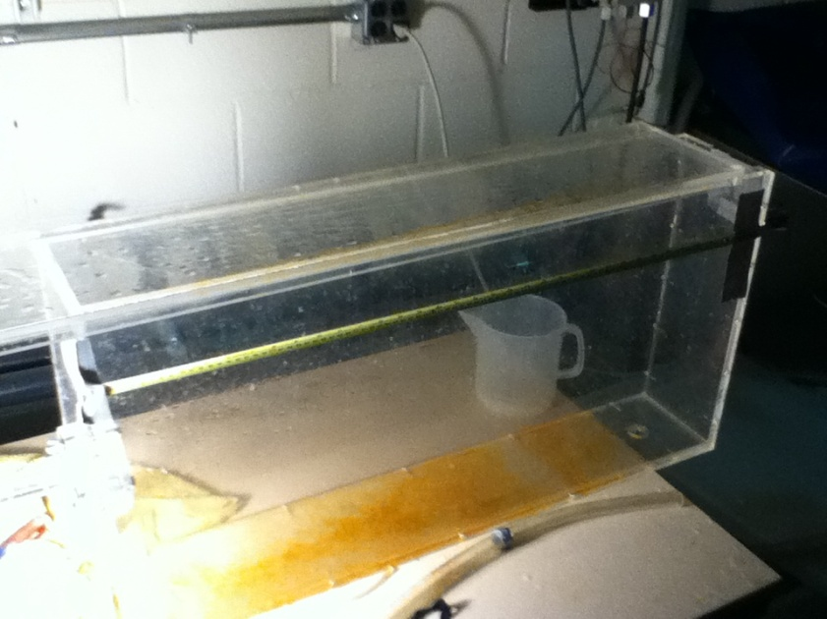The experimental setup of this apparatus is shown to the right. It consists of a large tank, with a drain on one side. A flow nozzle is connected to a high pressure pump, with a magnetic flow rate meter attached to this flow nozzle. A drain is on the right side of the tank to allow for the tank to drain while flow is being created. For this experiment, a measuring tape was attached to the side of the tank. This allowed for relative sizes to be determined in the pictures taken of the flow, thus for the wake length and vortices to be measured after the experiment had been performed.

Figure 1. Experimental Setup

Flow into a large tank and submerged jet mixing are an interesting phenomena, showing similar characteristics to that of flow around bluff bodies, and Karman vortices. In this case though, the radius is called stratification, which creates vortices. It has been experimentally proven to follow the relation $\frac{r_{\frac{1}{2}}\left(x\right)}{r_{0}}=0.848\left(4.39+\left(\frac{x}{r_{0}}\right)\right)$, where x is the downstream coordinate, r0 is the original radius, and r1/2 is the radius at half the velocity. This equation, when paired with the relation for the centerline velocity, which is given as $\frac{u_{cl}}{u_{0}}=\frac{13.14}{a+\frac{x}{r_{0}}}$, where a is the length of the tank and is much larger than x, give all the parameters of submerged jet mixing.

# Analysis and Discussion of Data

Through analysis of the data collected in this experiment, it is easy to illustrate the correlations between the Reynold’s Numbers and vortex properties of the flow in the tank. To rigorously evaluate all the options, it is needed to compare the time dependence of the vortexes against the flow velocity parameters. It is then needed to compare the spatial dependent parameters of flow against the same flow velocity parameters, and finally it is useful to evaluate the size of the nozzle used to compare to these same parameters.

The time dependent property of vortices is the frequency of the Karman vortices. These are calculated as in the sample calculations, and are related directly to the Reynold’s Number. Because of this direct dependence, the plot of these two shows two linear correlations. This is logical, as the vortices will occur faster as the flow into the tank goes faster and faster. The chart is shown below:

Figure 2.1 Frequency vs. Reynold's Number

After the time dependence is proven as a direct correlation, all of the spatial dependences must be compared. In this case, the spatial dependencies are the length of the wake and also the vortex diameter. When plotted, the length of the wake shows an exponential increase with increasing Reynold’s Number. The error must be large on the length of wake measurement, as it was hard to measure this on the pictures. The exponential increase is shown below, with error bars of an estimated 10% in the length of wake.

Figure 2.2 Length of Wake vs. Reynold's Numbers

The next spatial dependence shown is the vortex diameter versus the Reynold’s Number. This is even more error laden than the wake length, with up to 20% error estimated in the Vortex Diameter direction. The vortexes that were seen in the pictures were often not well defined, and sometimes nonexistent. It is a recommendation that either a better method be found for taking pictures of this flow, or that even a camera be provided for the lab group’s use. The quality of the pictures was low as they were taken on a cell phone camera. Regardless, it is obvious that this diameter again follows an exponential growth (particularly Nozzle 2 which looks to be fully developed). This is shown below.

Figure 2.3 Vortex Diameters vs. Reynold's Numbers

The final analysis to complete is an evaluation of the size of the nozzle versus the spatial dependences of the turbulence. This is manifested in a table that shows the comparisons. Upon inspection, it is easy to see that there is an indirect correlation between the size of the nozzle and vortex diameter, and there is an indirect relation between the nozzle size and the wake length. The error in this analysis is simply in the error of measuring distances.

|  |  |  |  |  |  |  |  |
| --- | --- | --- | --- | --- | --- | --- | --- |
|  | Entrance Diameter (m) | | Exit Diameter (m) | Min Vortex Diameter (m) | Max Vortex Diameter (m) | Min Wake Length (m) | Max Wake Length (m) |
| 1 | | 0.0252±.00254 | 0.0189±.00254 | 0.0222±.00254 | 0.0254±.00254 | 0.121±.00254 | 0.292±.00254 |
| 2 | | 0.0249±.00254 | 0.0125±.00254 | 0.0254±.00254 | 0.127±.00254 | 0.0889±.00254 | 0.400±.00254 |

Table 2.1 Nozzle Size and Wake and Vortex Properties

# Conclusions

Throughout this experiment, a rigorous analysis of flow through a nozzle into a bulk liquid was performed. The analysis included three parts. The first part was analysis of the time dependence of the turbulence in the flow and its relation to the flow velocity. The next part was analysis of the spatial dependencies against the Reynold’s Number, followed finally by analysis of the flow parameters depending on the size of the nozzle.

The analysis of the time dependence of vortices against the Reynold’s Number provided less than insightful results. Because of the dependence of Reynold’s Number on flow velocity, and also the Vortex Frequency’s dependence on flow velocity, the correlation is directly linear. The Reynold’s Numbers ranged from 72458.23 up to 310336.9, and the Vortex Frequencies ranged from 42.503 all the way up to 414.762 Hz.

The spatial analysis of the Reynold’s Number effect on the turbulence yielded much more interesting results. The wake length showed the strongest correlation, making an almost perfect exponential increase as the Reynold’s Number increased. Nozzle 1 showed this the best, with the wake length starting at .121 m and .127 m but then shooting up to .292 m quickly. This is logical, as the faster a flow occurs, the further it can project into the tank before being disrupted by the bulk liquid.

Although the wake length yielded a good, logical correlation, the vortex diameter was not quite as perfect as the wake length. Because of the picture quality and flow characteristics, it became very difficult to measure the vortex diameter. This lead to several flows as not having a vortex able to be measured, and the others with an assumed error of 20% in the measurement of the vortex. Albeit the measurement was not perfectly executed, the exponential correlation was still shown in the plot. The vortex diameter for Nozzle 2 started at 0.0254 m but quickly shot up to .127 m as the Reynold’s Number increased. This also follows an understandable, creating a larger disturbance with more velocity.

The last part of the analysis was to compare the effects on flow with the different size nozzles. The nozzle had effect on the time dependencies of the flow, but that has already been shown in the previous analyses. The wake length and vortex diameter do show an interesting correlation when paired with the nozzle size. The vortex diameter has an indirect relationship with the nozzle size, with the smaller nozzle (Nozzle 2) getting up to a diameter of .127 m compared to the diameter of .0254 for Nozzle 1. The Wake length also showed this correlation, with the max up to .400 m for the Nozzle 2, compared against .2921 m in Nozzle 1. This shows that a more concentrated flow (which will have higher velocities for the same flow rate) will create more of a disturbance in the bulk liquid than a less concentrated flow.

# Works Cited

Munson, Y. O. (2009). *Fundamentals of Fluid Mechanics.* Hoboken, NJ: Wiley and Sons, Inc.

Revankar, S. (2011). *Experiment #5: Turbulence and Vortex Visualization in Vertical Channel.* West Lafayette, IN: Purdue University School of Nuclear Engineering.

# Appendices

## Original Data

### Nozzle 1

|  |  |  |
| --- | --- | --- |
| Trial | Entrance Diameter (in) | Exit Diameter (in.) |
| 1 | 0.993 | 0.744 |
| 2 | 0.989 | 0.746 |
| 3 | 0.99 | 0.747 |
| Average | 0.991 | 0.746 |

Table 5.1 Nozzle 1 Properties

|  |  |
| --- | --- |
| Flow | Flow Rate (m^3/h) |
| 1 | 11.486 |
| 2 | 10.903 |
| 3 | 7.878 |
| 4 | 3.888 |
| 5 | 7.010 |

Table 5.2 Nozzle 1 Flow Data

### Nozzle 2

|  |  |  |
| --- | --- | --- |
| Trial | Entrance Diameter (in) | Exit Diameter (in.) |
| 1 | 0.979 | 0.492 |
| 2 | 0.978 | 0.496 |
| 3 | 0.98 | 0.494 |
| Average | 0.979 | 0.494 |

Table 5.3 Nozzle 2 Properties

|  |  |
| --- | --- |
| Flow | Flow Rate (m^3/h) |
| 1 | 11.032 |
| 2 | 10.157 |
| 3 | 8.561 |
| 4 | 6.205 |
| 5 | 2.664 |

Table 5.4 Nozzle 2 Flow Data

Pictures are also part of the original data and were used to measure the length of the jet and the spreading.

## Reduced Data

|  |  |  |  |  |  |  |
| --- | --- | --- | --- | --- | --- | --- |
| Flow | Flow Rate (m^3/s) | Velocity (m/s) | Re | Vortex Frequency (Hz) | Wake Length (m) | Vortex Diameter (d) |
| 1 | 0.00319 | 11.325 | 214057.4 | 125.563 | 0.292 | 0.0254 |
| 2 | 0.00303 | 10.750 | 203192.4 | 119.189 | 0.184 | 0.0222 |
| 3 | 0.00219 | 7.767 | 146817.4 | 86.121 | 0.133 | -- |
| 4 | 0.00108 | 3.833 | 72458.23 | 42.503 | 0.127 | -- |
| 5 | 0.00195 | 6.911 | 130641 | 76.632 | 0.121 | -- |

Table 5.5 Nozzle 1 Flow Properties

|  |  |  |  |  |  |  |
| --- | --- | --- | --- | --- | --- | --- |
| Flow | Flow Rate (m^3/s) | Velocity (m/s) | Re | Vortex Frequency (Hz) | Wake Length (m) | Vortex Diameter (d) |
| 1 | 0.00306 | 24.782 | 310336.9 | 414.762 | 0.400 | 0.127 |
| 2 | 0.00282 | 22.817 | 285722.7 | 381.865 | 0.191 | 0.0254 |
| 3 | 0.00238 | 19.231 | 240826.2 | 321.862 | 0.152 | 0.0191 |
| 4 | 0.00172 | 13.939 | 174550.5 | 233.285 | 0.140 | 0.0254 |
| 5 | 0.000740 | 5.984 | 74939.96 | 100.156 | 0.0889 | -- |

Table 5.6 Nozzle 2 Flow Properties

## Sample Calculations

### Velocity

$$Q=VA$$

$$V=\frac{Q}{A}=\frac{4Q}{πD^{2}}=\frac{4\left(.003191\frac{m^{3}}{s}\right)}{π{\left(.0189 m\right)}^{2}}=11.325\frac{m}{s}$$

In this case, the highest velocity occurs at the smallest diameter, so the exit diameter is taken into account.

### Reynold’s Number

In this case the highest Reynold’s Number occurs at the highest velocity, so the exit diameter is taken into account.

$$Re=\frac{ρVd}{μ}=\frac{\left(1000\frac{kg}{m^{3}}\right)\left(11.325\frac{m}{s}\right)\left(0.0189 m\right)}{1.002*{10}^{-3}}=214057.4$$

### Vortex Frequency

$$V=\frac{fD}{s}$$

$$s=0.21 for Re>100$$

$$f=\frac{Vs}{D}=\frac{\left(11.325\frac{m}{s}\right)\left(0.21\right)}{0.0189 m}=125.563 s^{-1}$$

### Wake Length and Vortex Size

Wake Length is measured on the pictures against the scale placed in the pictures. An Example of the process is shown below:

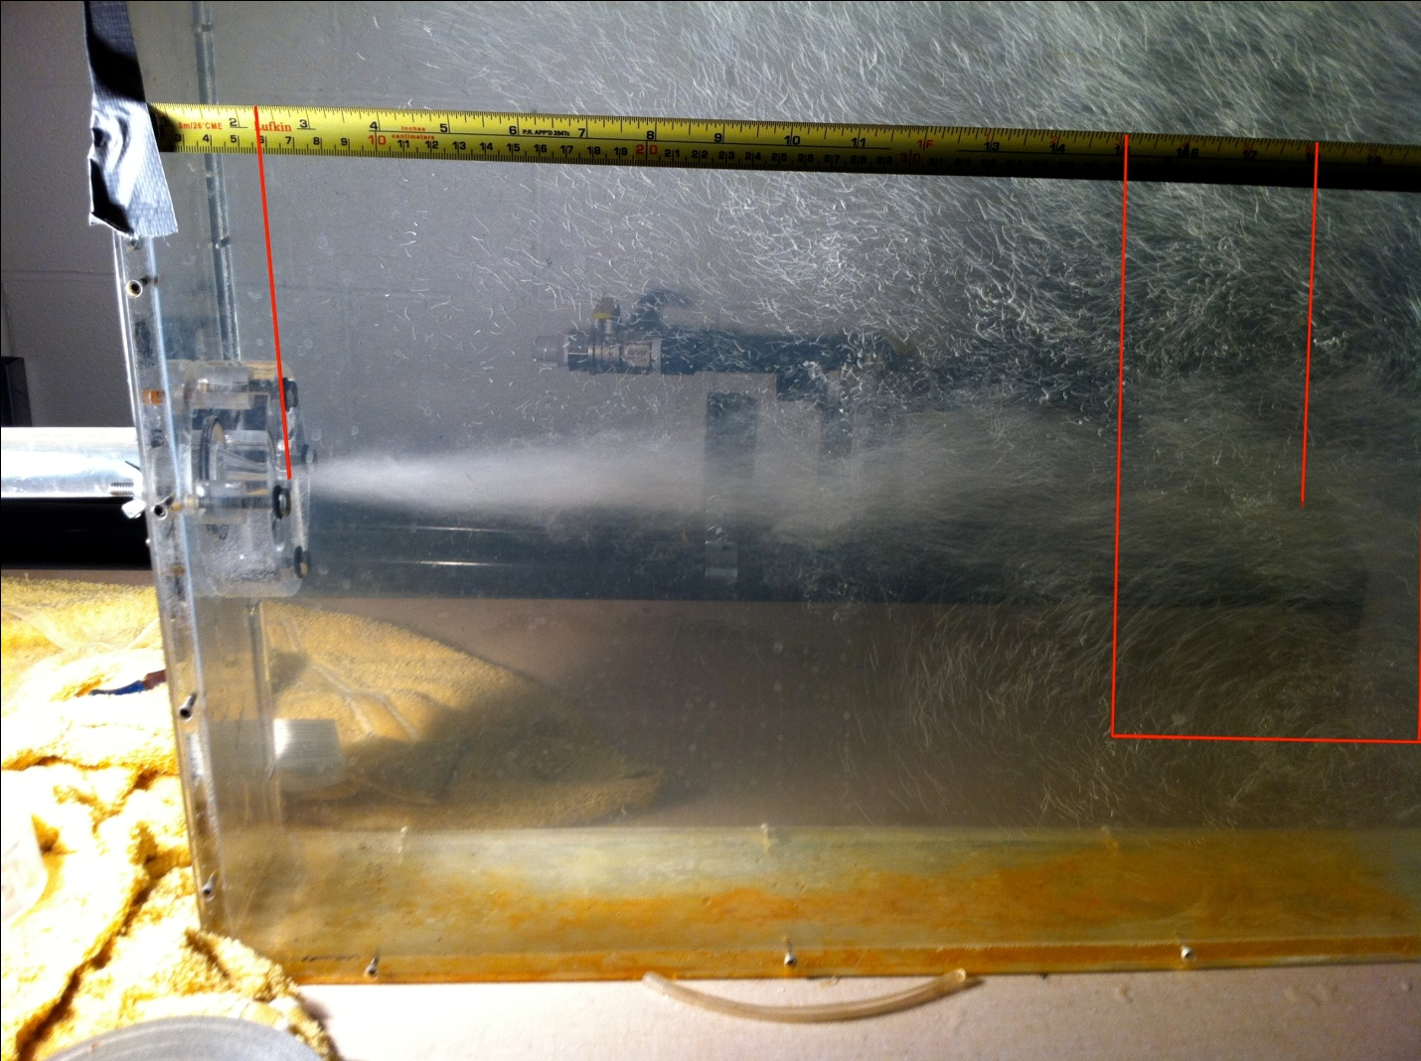

Figure 5. Nozzle 2 Flow 1 Measurements